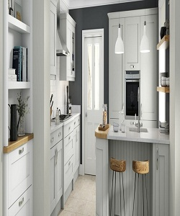

Universal Kitchen Cabinets

$230.49

Availability: In stock

Description

Modern of white tall Kitchen Cabinets. Matte white tabletop cabinets. Milk white painted door, soft close hinges, drawer boxes and lifting mechanisms. Full assembly instructions are included in the box, certified for the highest quality.